**T&T LAB PROJECT :**

**PROJECT NAME: TIC-TAC-TOE GAME USING PYTHON.**

**GROUP:4(Deepak sir’s)**

**Name of the members:**

**PROJECT REPORT:**

**1.OBJECTIVE:**

Our project name is Tic tac toe game. This game is very popular and we all have played in our childhood. It is actually a two player game. In this game ,there is board with n*n squares. And in our project , it is 3*3 squares. So, basically the goal of this is to be one of the players to get the same symbols in a row - horizontally,vertically or diagonally on 3*3 grid.

**2.OVERVIEW:**

This game can be played in a 3*3 grid as shown in the figure below, and this can be played by two players.



2.1 PLAYERS:

Here both the players are human ,one is labelled as player 1 and other as player 2.

2.2 THEORY OF THE GAME:

A player has to choose between two symbols with his opponent, usual games use ‘X’ and ‘O’. If first player(Player 1) choose ‘X’ then the second play with ‘O’ and vice versa.

A player mark any of the 3*3 square with the symbol that the player selected and his aim should be to create a straight line horizontally or vertically or diagonally with two intentions:

1. Create a straight line before his opponent to win the game
2. Restrict his component from creating a straight line.

In case, if both of them fails to create a straight line then in that case the game will be draw.

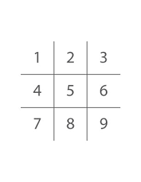

If any player is able to draw three X or three O in the following combinations then that player wins

And the combination are as follows:

1. (1,2,3)
2. (4,5,6)
3. (7,8,9)
4. (1,4,7)
5. (2,5,8)
6. (3,6,9)
7. (1,5,9)
8. (3,5,7)
9. CORE LOGIC(HUMAN):

For each move , Whether 3 combinations is occupied by any player and then display the result accordingly.

1. PYTHON LIBRARY:

In this project we have imported “from IPython.display import clear_output”. We have imported this to clear output of the cell .

1. OUTPUT SCREEN:

5.1. After running the code we will get the below screen on our system



5.2.Then after choosing ‘X’ or ‘O’ ,we will get a screen like :

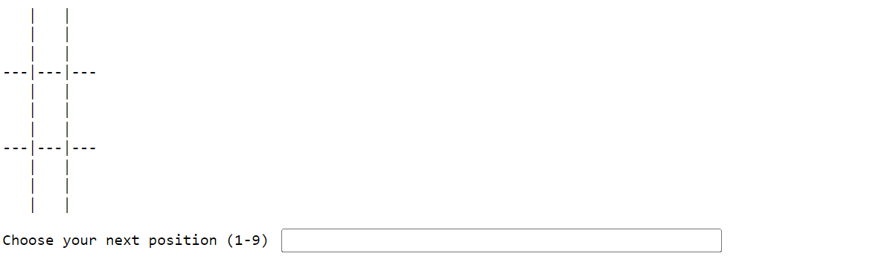

5.3.After playing the game it will show the result accordingly ,

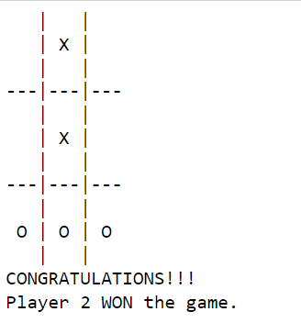

5.4.Then it will ask whether we want to play again,So we will get a screen like this:

